NAME :- NISHITA MANHARSINH SOLANKI

ROLL NO. : - 22BCE211

SUBJECT :- CLOUD NATIVES AND DEVOPS

PRACTICAL :- 1

AIM :- Version Control with Git: Task-Oriented Hands-on Lab

Task 0: Install Git

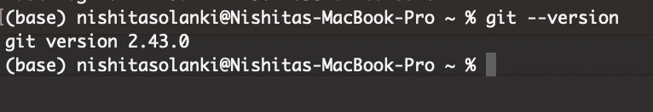

Task 1 : Configure Git

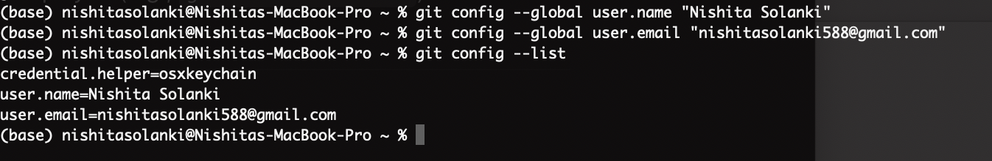

Task 2: **Initialize Local Repository**

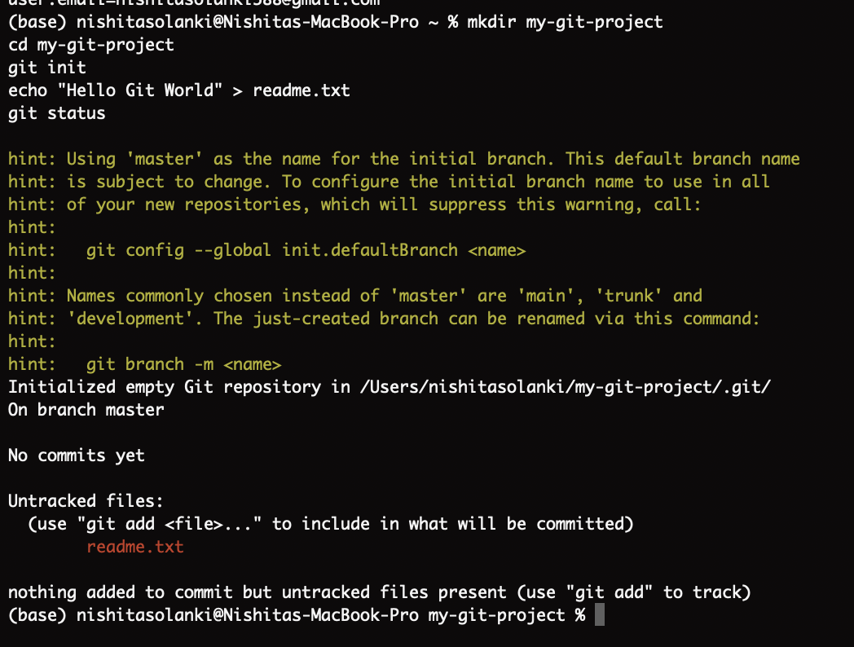

Task 3: **Stage and Commit Changes**

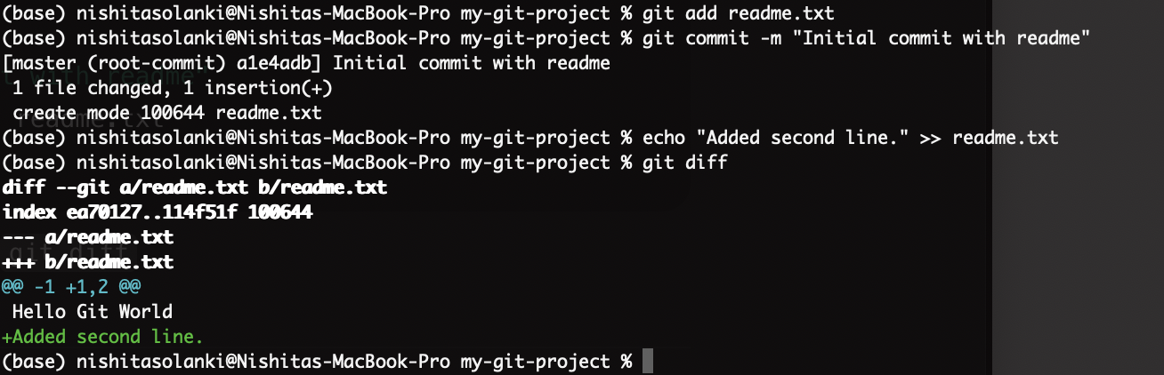

Task 4: View History and Revert

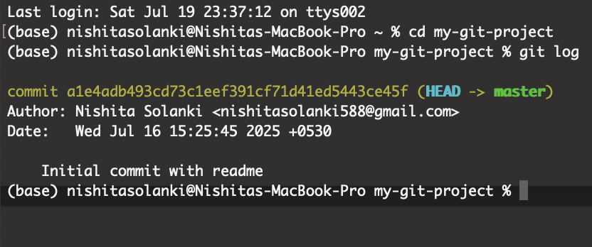

**Task 5: Create GitHub Repository**

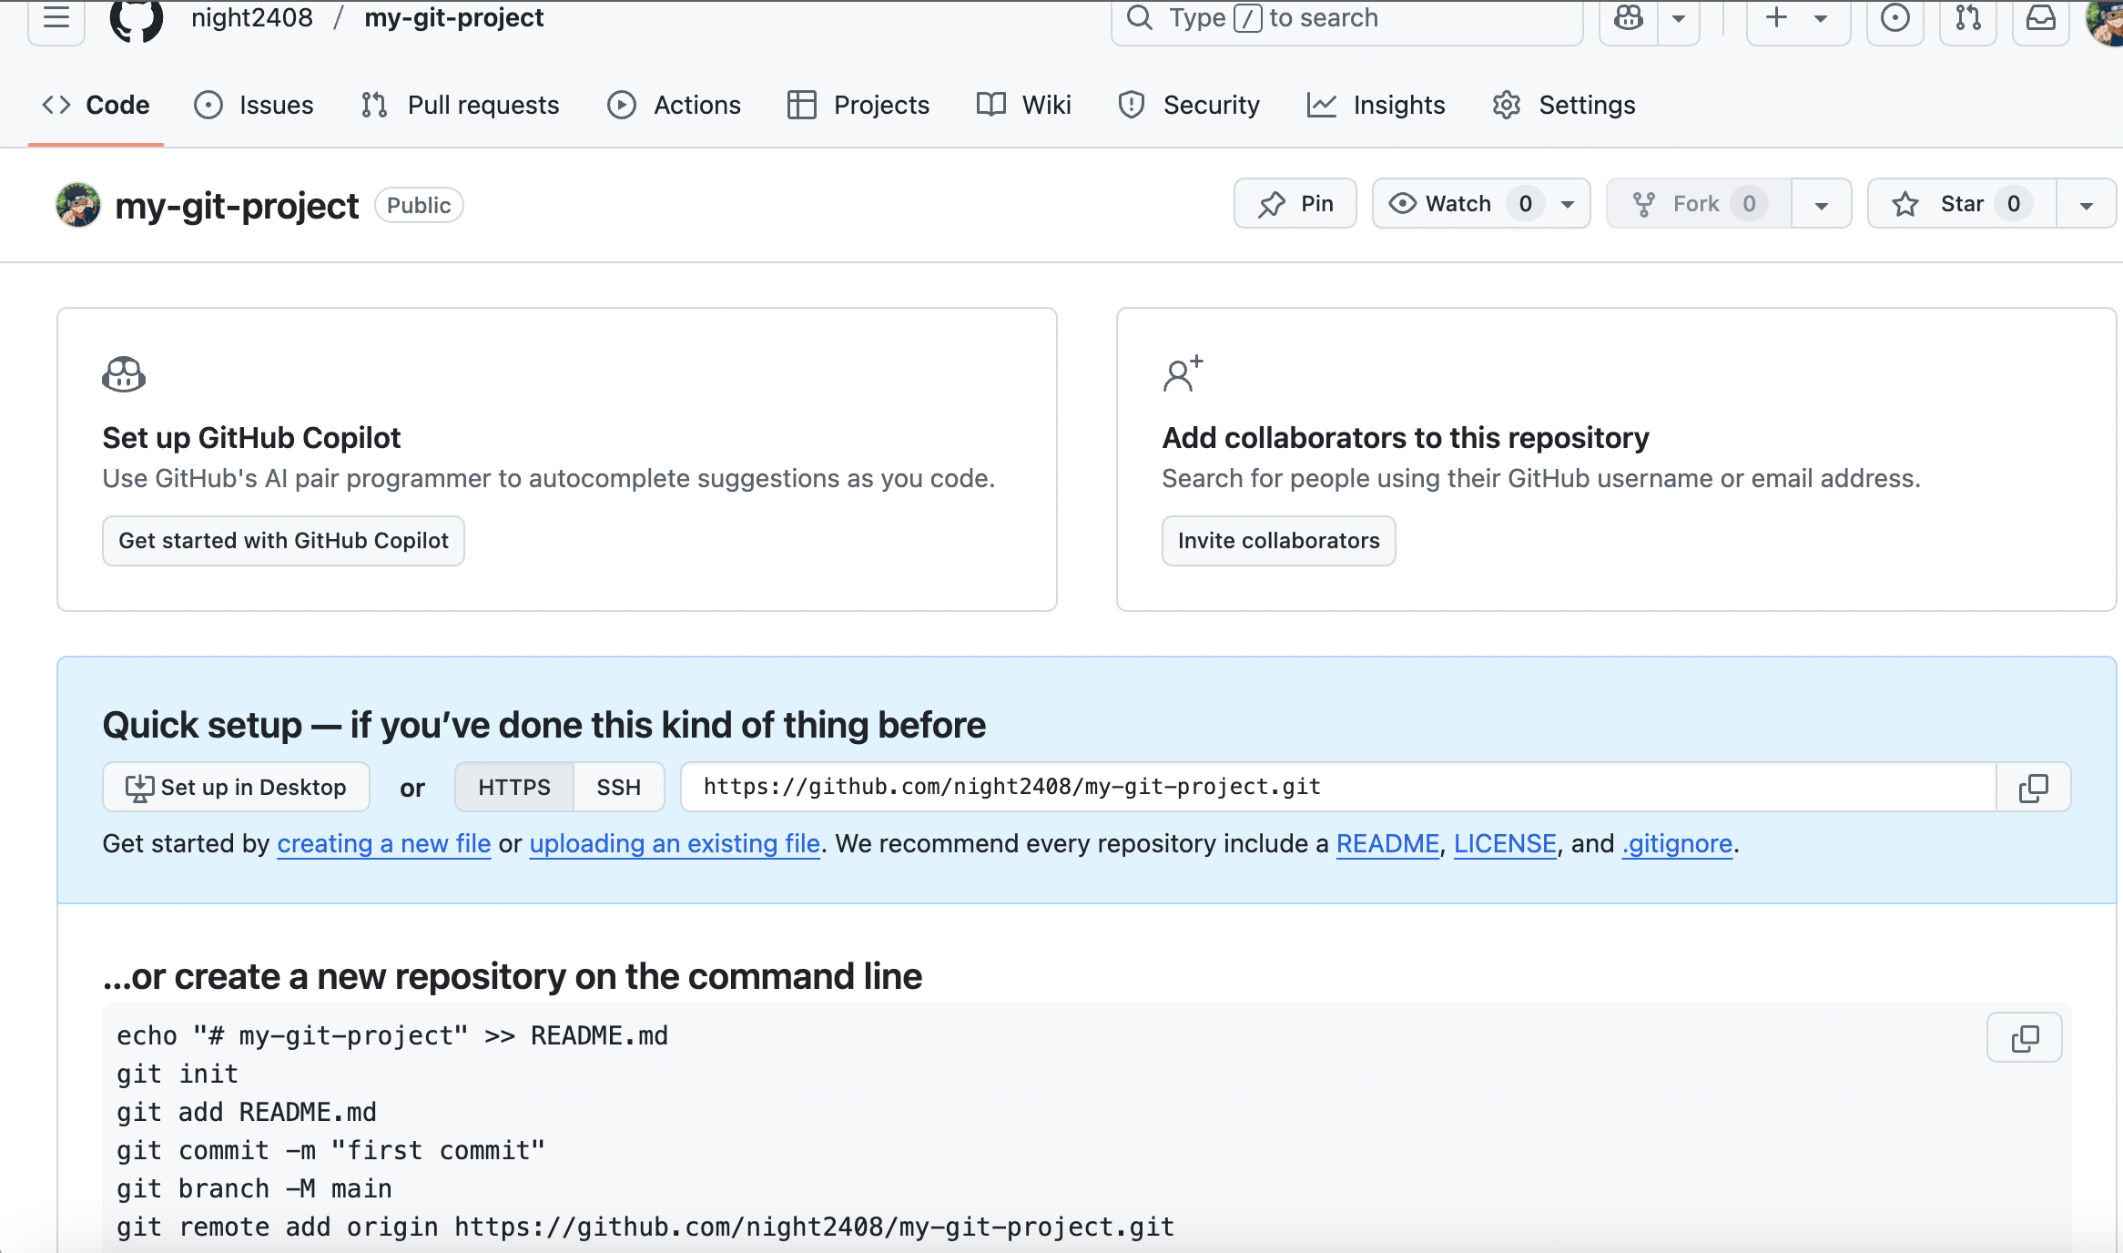

**Task 6: Connect Local Repo to GitHub**

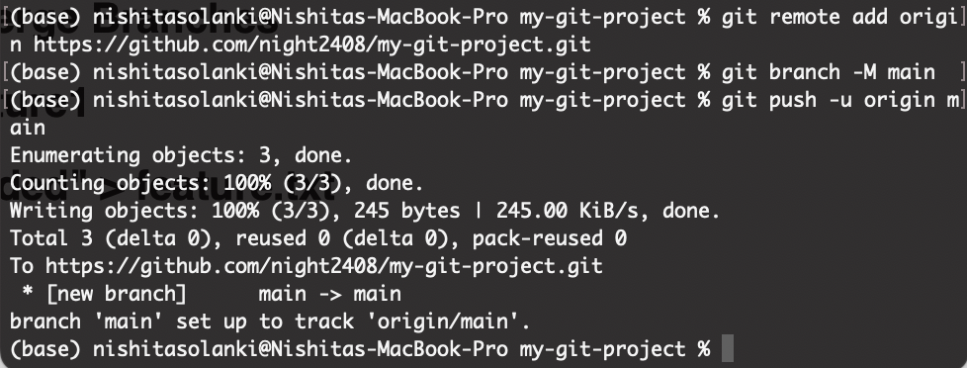

**Task 7: Create and Merge Branches**

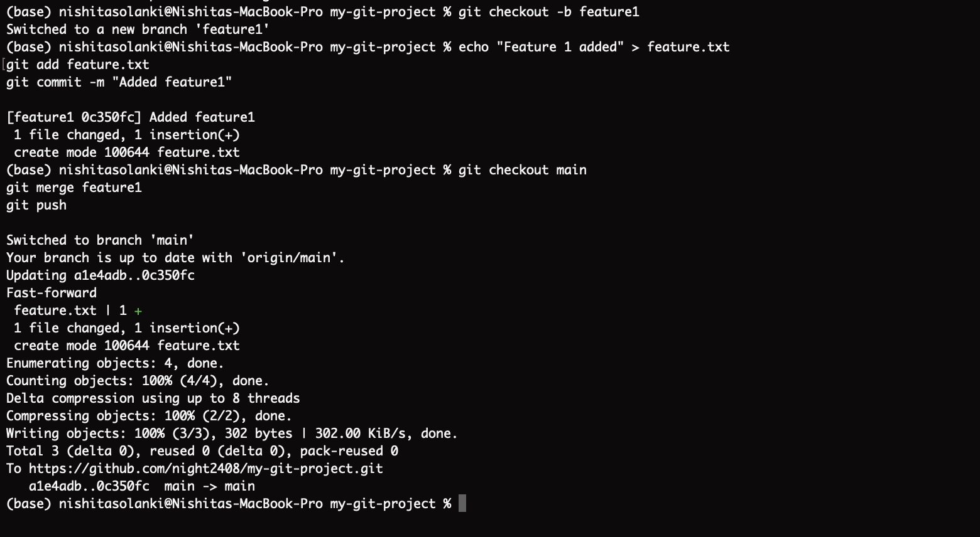

**Task 7: Create and Merge Branches**

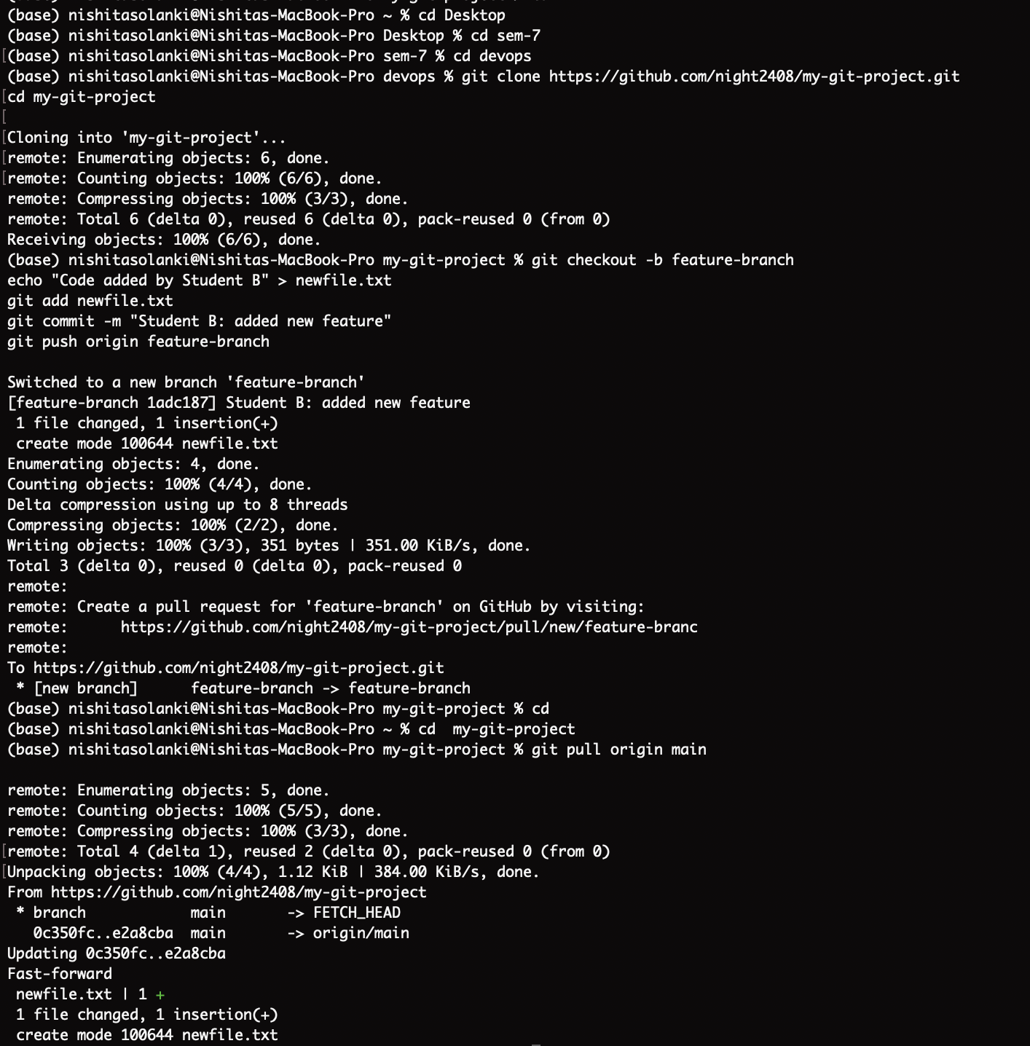

**Task 8: Two-Person Collaboration Workflow**

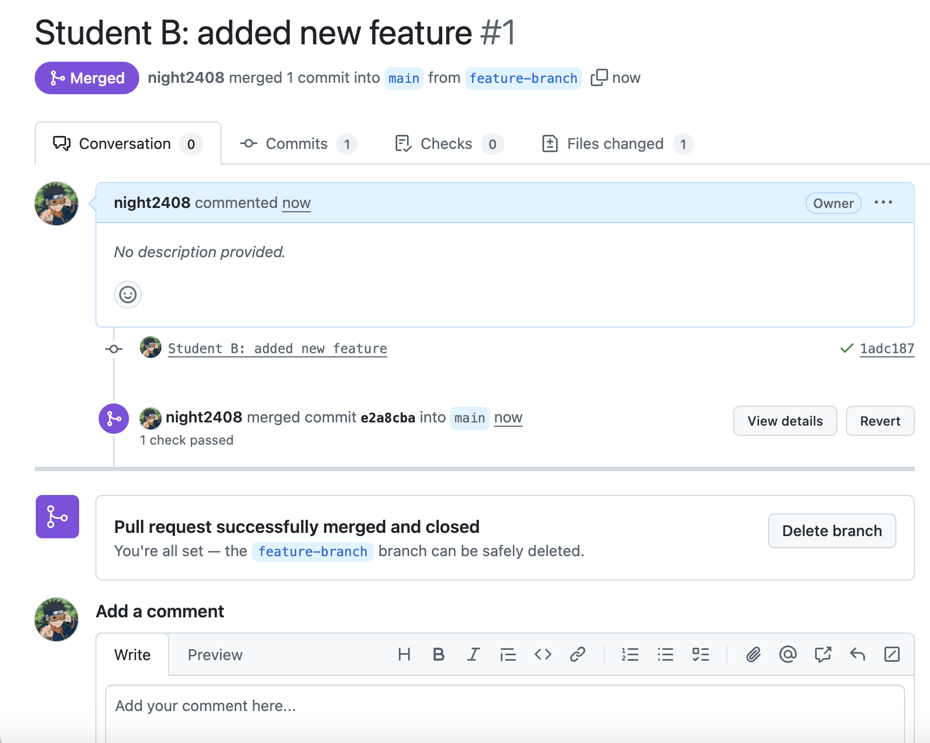

Student – A

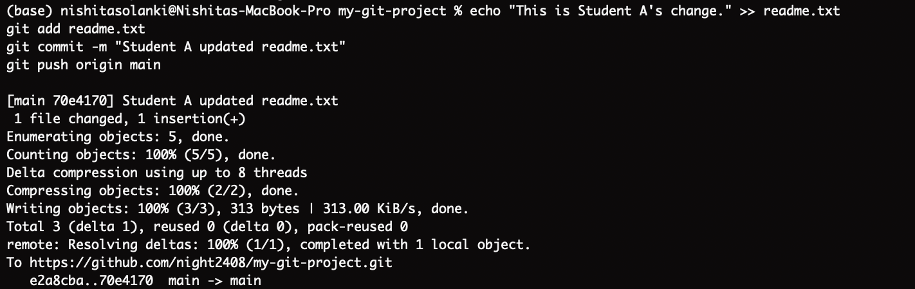

Student – B

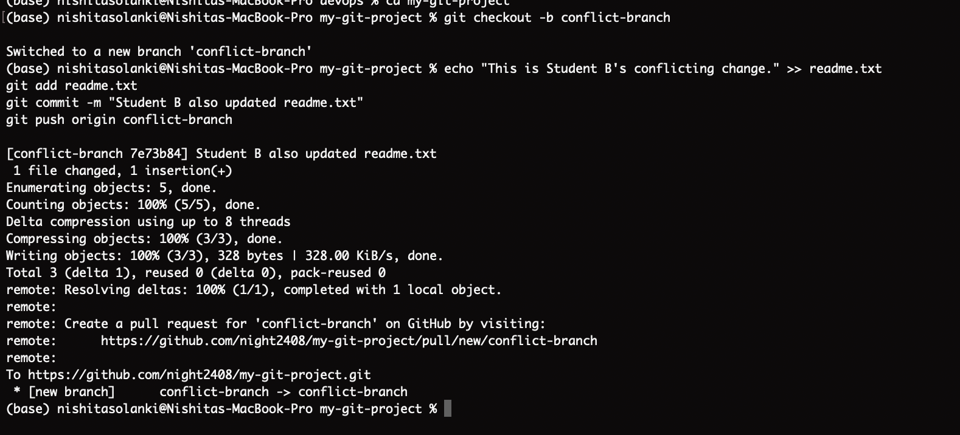

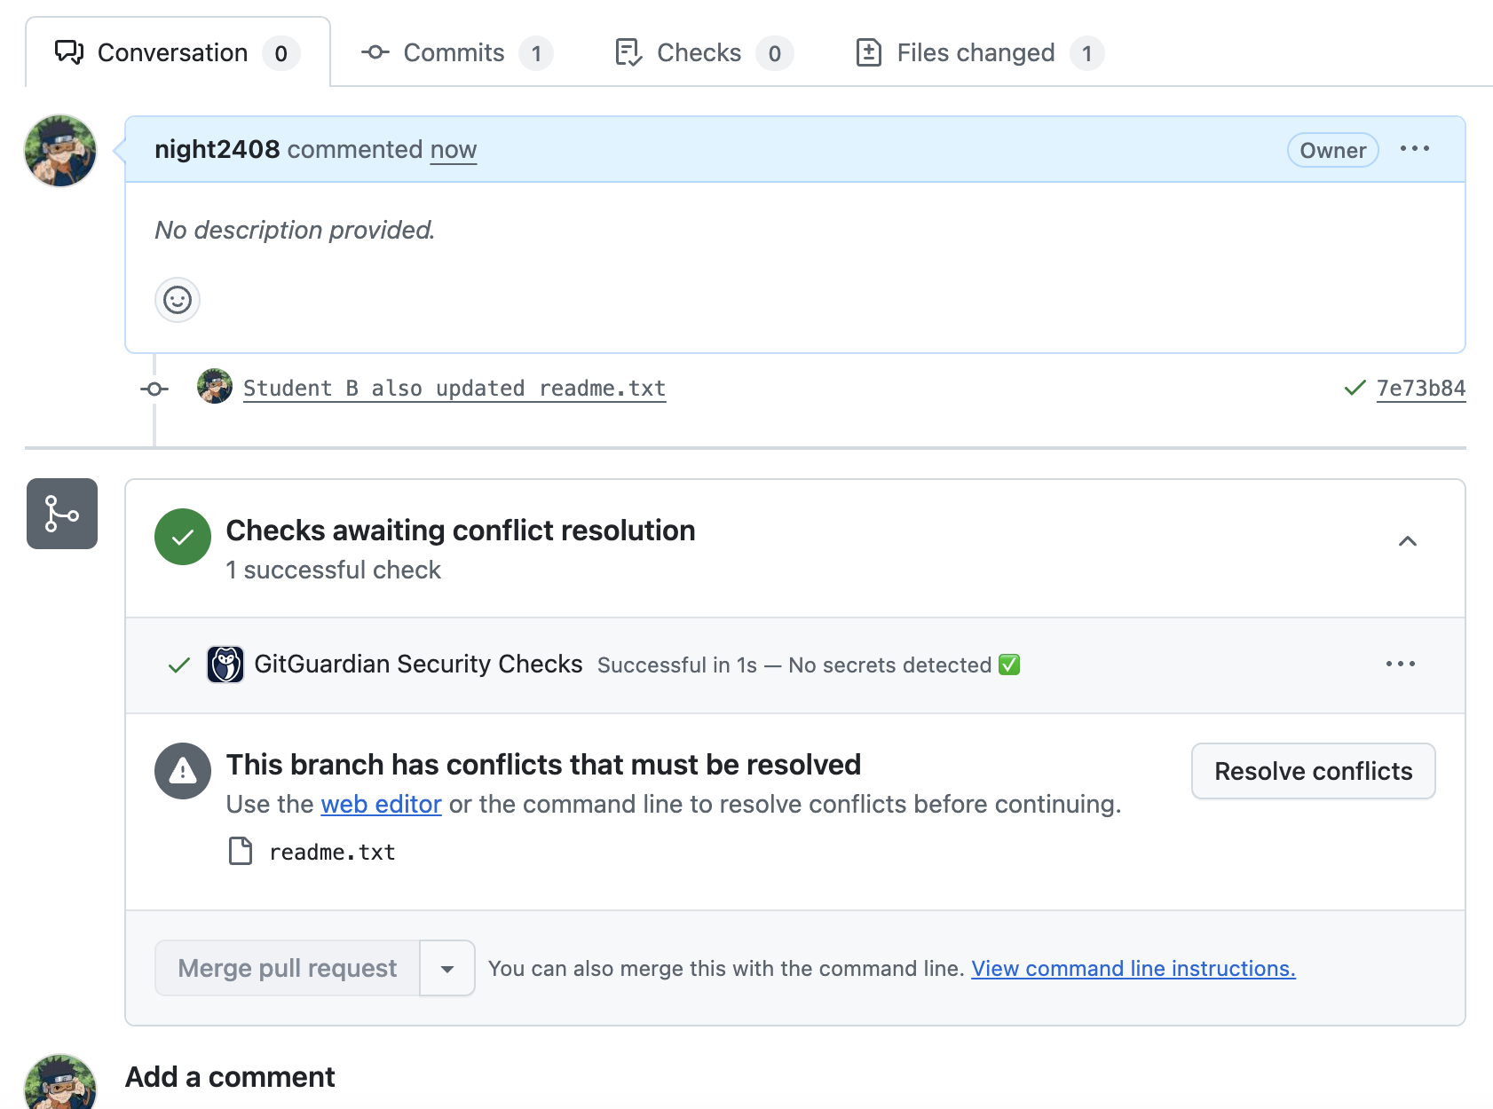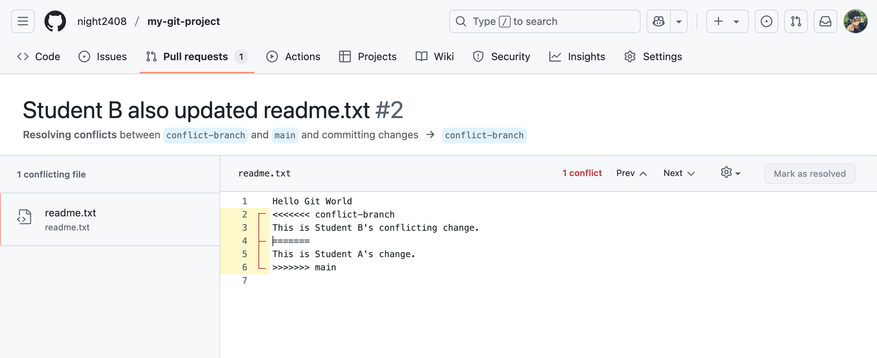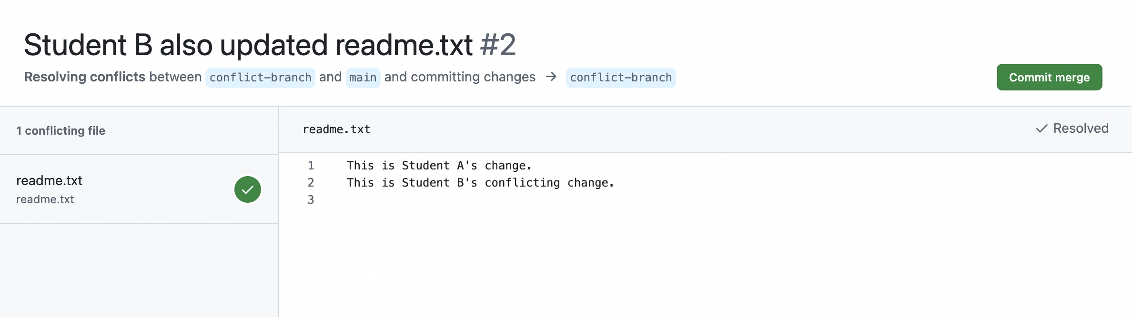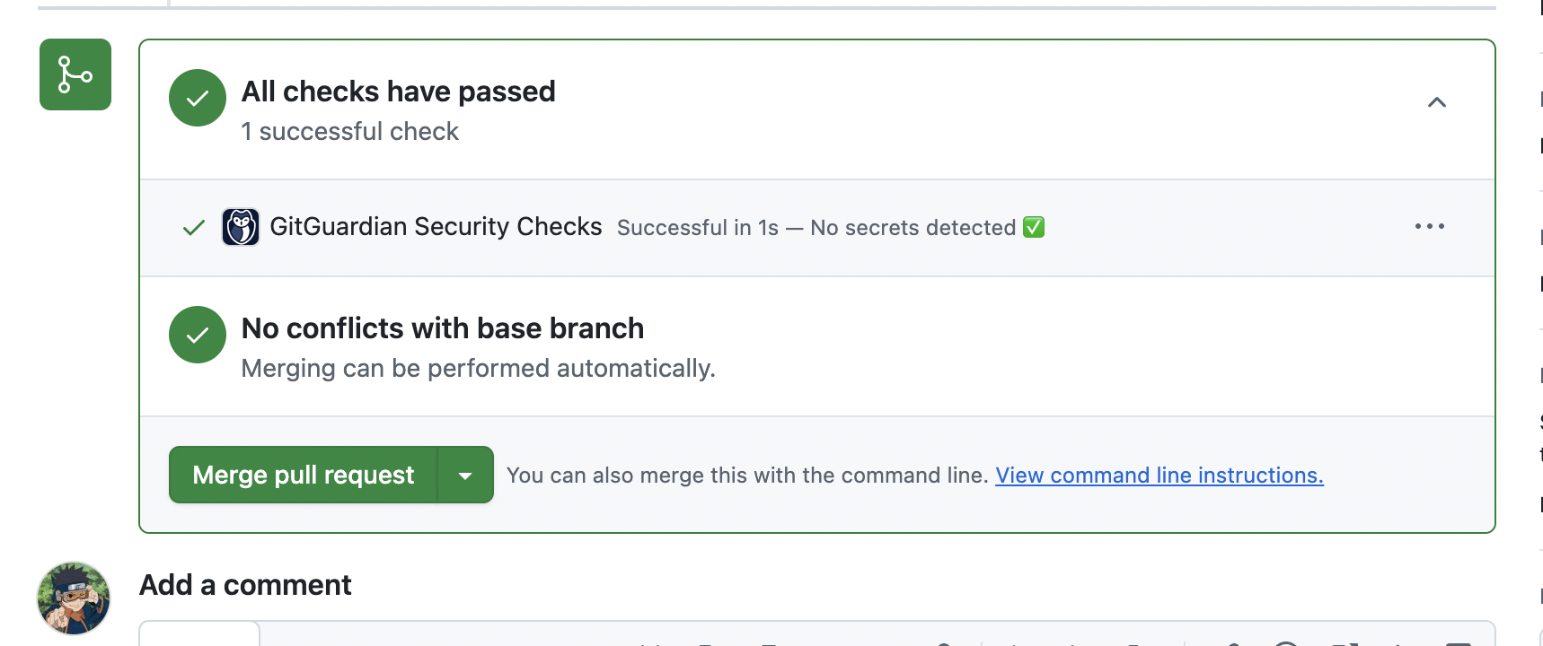

Repo link : https://github.com/night2408/my-git-project